Name – Harshad Khedekar
Email – harshadkhedekar123@gmail.com

- What do you mean by cells in an excel sheet?

- A cell is an area on a spreadsheet or excel sheet where we enter a data.
- Cells may contain Labels, Numbers, Formulas or Functions.
- Each cell acts as an individual entity
- Also called as, cell is a rectangular area formed by the intersection of a column and a row.
- Every Cells are identified by the Cell Name, which is found by combining the Column Letter with the Row Number.
- We can say that, A cell is the basic unit of data entry in a spreadsheet.

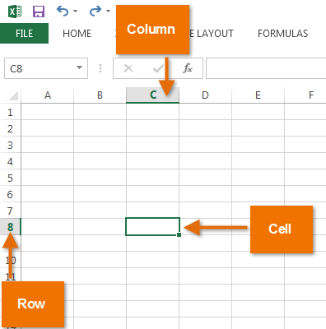
- How can you restrict someone from copying a cell from your worksheet?
In order to protect your worksheet from getting copied, you need to go into
- Menu bar
- Review
- Protect sheet
- Set Password.
Another method –
- STEP 1: Right click on your sheet. In the panel below you can see there is “Sheet1 or Sheet name” written in green. Right click on that.
- STEP 2: you must click on ‘Protect Sheet’.
- STEP 3: Enter the password with which you want to protect the sheet. You will see that there are two checkboxes which are automatically ticked for you. Leave it as it is.
Re-enter your password and click on ‘OK’.

- How to move or copy the worksheet into another workbook?
‘Move’ a worksheet within a workbook
- Select the worksheet tab, and drag it to where you want it.
‘Copy’ a worksheet in the same workbook
- Press CTRL and drag the worksheet tab to the tab location you want.
OR
- Right click on the worksheet tab and select Move or Copy.
- Select the Create a copy checkbox.

- Which key is used as a shortcut for opening a new window document?

- Press Alt+F to open the File menu. KeyTips are displayed over the File menu page options.
- On your keyboard, press the key that matches the letter in the KeyTip of the page to select and open the page. For example, to open the New page in Word, press N.
- The page opens, and a new set of KeyTips are displayed over the options of the selected page.
- To select an option on the page, press the keyboard key matching the KeyTip letter.
- For example, on the New page in Word, press S to go to the Search field for online templates.
Another Method –
- To open new tab on single sheet , you can do it on pressing
Ctrl + N

5. What are the things that we can notice after opening the Excel interface?
There are many things like
Toolbars, Name Box, Formula Bar, Worksheet Window, Column, Cell Headings, Row Headings, Sheet Tabs, Navigation Buttons etc.
After opening Excel –
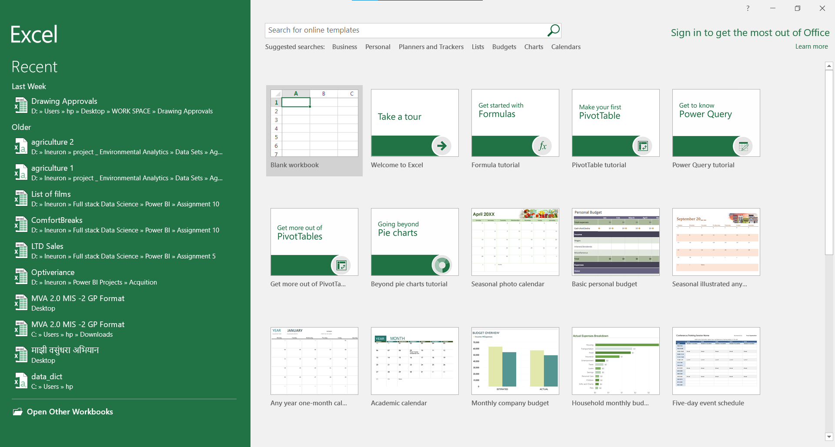
After clicking blank workbook –
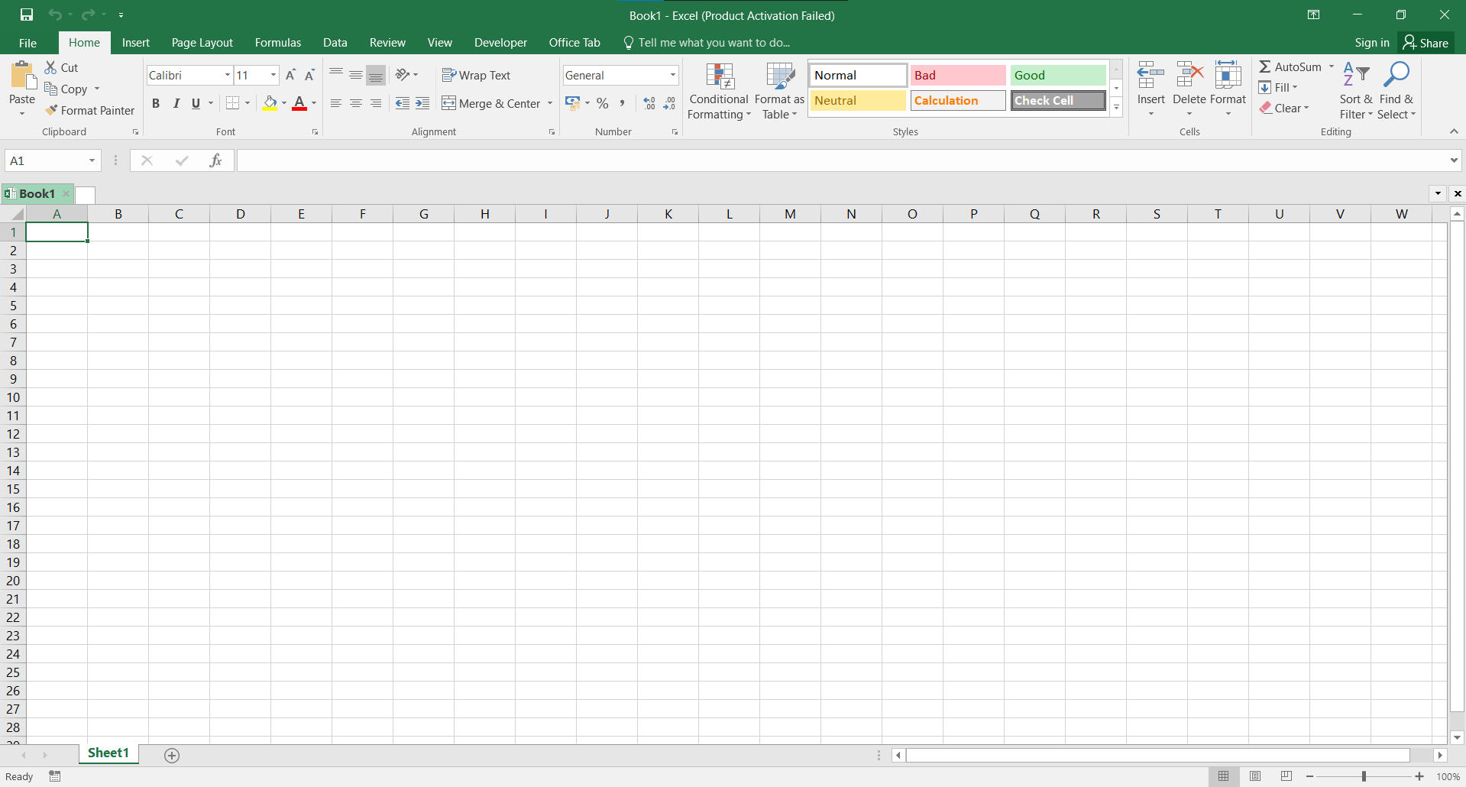
6. When to use a relative cell reference in excel?
- Relative references are used when we want to perform a similar operation on multiple cells and the formula must change according to the relative address of column and row.
- Relative reference is the default cell reference in Excel.
- It is simply the combination of column name and row number without any dollar ($) sign.
- When you copy the formula from one cell to another the relative cell address changes depending on the relative position of column and row. C1, D2, E4, etc. are examples of relative cell references.
- For example, we want to add the marks of two subjects entered in column A and column B and display the result in column C. Here, we will use relative reference so that the same rows of column’s A and B are added.

